Latin America Conquests and Conquistadors Graphic Organizer

Aztecs

Hernan Cortes

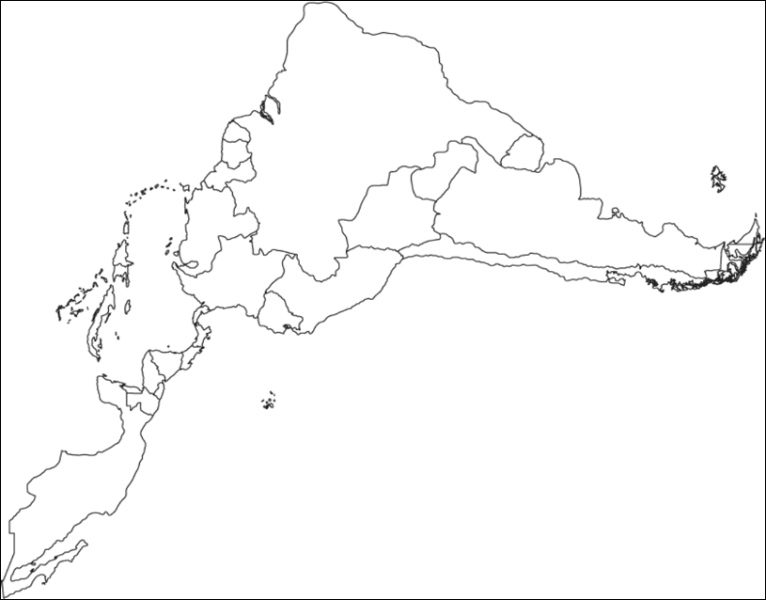

Inca

Francisco Pizarro

.